**PRACTICAL –8**

**Q. Write a program to use Ultrasonic sensor with LCD to get output on its screen.**

Ultrasonic distance sensors are designed to measure distance between the source and target using ultrasonic waves. We use ultrasonic waves because they are relatively accurate across short distances and don’t cause disturbances as they are inaudible to human ear.

HC-SR04 is a commonly used module for non contact distance measurement for distances from 2cm to 400cm. It uses sonar (like bats and dolphins) to measure distance with high accuracy and stable readings. It consist of an ultrasonic transmitter, receiver and control circuit. The transmitter transmits short bursts which gets reflected by target and are picked up by the receiver. The time difference between transmission and reception of ultrasonic signals is calculated. Using the speed of sound and ‘**Speed = Distance/Time**‘ equation, the distance between the source and target can be easily calculated.

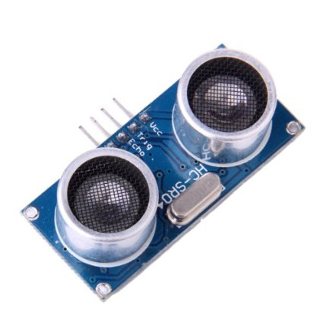

**HC-SR04 ultrasonic distance sensor module has four pins :**

• VCC – 5V, input power

• TRIG – Trigger Input

• ECHO – Echo Output

• GND – Ground

**Hardware:-**

* Raspberry pi
* Ultrasonic Sensor HC-SR04
* LCD Display
* 10k ohm potentiometer
* Breadboard and wires

**Connection:-**

**Ultrasonic Sensor HC-SR04:**

The HC-SR04 Ultrasonic Module has 4 pins, Ground, VCC, Trig and Echo. The Ground and the VCC pins of the module needs to be connected to the Ground and the 5 volts pins on the Arduino Board respectively and the trig and echo pins to any Digital I/O pin on the Arduino Board.

* The HC-SR04 sensor attach to the Breadboard
* The Sensor VCC connect to the Raspberry pi +5V
* The Sensor GND connect to the GND
* The Sensor Trig connect to the Raspberry pi I/O 9
* The Sensor Echo connect to the Raspberry pi I/O 10

**Code:-**

import Rpi.GPIO as GPIO

import time

GPIO.setmode(GPIO.BCM)

GPIO_TRIGGER=18

GPIO_ECHO24

GPIO.setup(GPIO_TRIGGER,GPIO.OUT)

GPIO.setup(GPIO_-ECHO,GPIO.IN)

Def distance():

GPIO.output(GPIO_TRIGGER,True)

Time.sleep(0.0001)

GPIO.output(GPIO_TRIGGER,False)

StartTime=time.time()

StopTime=time.time()

while GPIO.input(GPIO_ECHO) == 0:

StartTime = time.time()

while GPIO.inut(GPIO_ECHO) ==1:

StopTime=time.time()

TimeElapsed=StopTime-StartTime

distance=(TimeElapsed * 34300)/2

Return distance

if__name__ == ‘__main__:

try:

while True:

distance=distance()

print(“Me91asured Distance=%.1f cm”%dist)

time.sleep(1)

except KeyboardInterrupt:

print(“Measur9ement stopped by user”)

GPIO.cleanup()

**OutPut:-**

